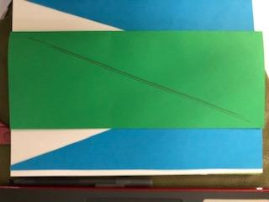 | 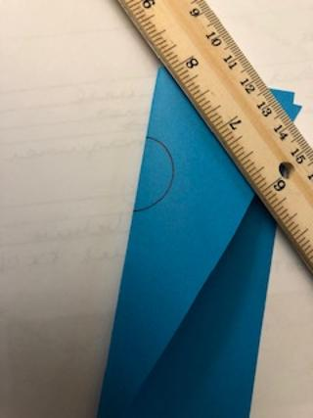 | 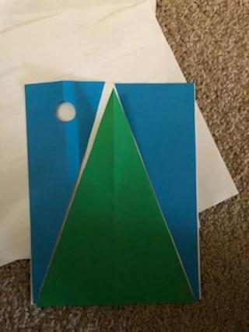
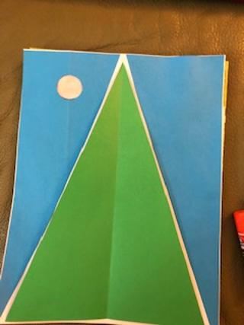 |  | 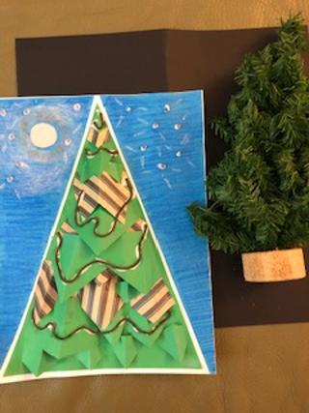
This is Ms. Susan from the Shorewood Public Library. The first night of winter is just a few weeks away. You can often look out your window and see a dark, starry sky, you wouldn’t believe. It seems that in the winter sky, all the stars shine and sparkle much brighter. The trees will soon have snow and the air will be cold, but we can snuggle inside and be grateful for the warmth of the season. I am wishing each of you a wonderful, artful holiday season and hope you share your special gifts with family and friends. The best gifts are inside each and every one of my artCart friends.
1-If you do not have blue, black or green paper, just cut the pages out as follows and color after. Fold one blue piece of paper in half lengthwise. Draw a line from one corner to the opposite corner. Now cut on this line. Take one of the end pieces and draw a circle about a quarter size, on the larger end. This will be the night moon. If you fold the end piece in half at the middle of the circle, it will be easy to cut out. Tape a soft fabric, wax paper, or plastic wrap on the back of the circle. Fold the green piece of paper in half lengthwise and draw the same line from corner to opposite corner. Cut on this line. Now draw a line about 1/8” inside of the cut line, away from the fold. This will be your winter tree and the new cut will make it just a bit smaller. When you glue it down on white paper, this space will create dramatic contrast between the triangles. Glue the two blue ends onto the edges of a piece of white paper. Glue the green triangle in the center. With the pieces, you can create another picture or share with someone, to make their own dark, starry night creation.
2-This is where your imagination can create a starry sky, where you would want to gaze and make a special wish. Use crayons, little pieces of paper, yarn, or anything to create texture or an interesting design to the tree. Use glitter or shiny crayons to make stars in the sky or add a bit of snow. “I wish I may, I wish I might, wish upon a star tonight!”
Look to the stars, and make a wish for peace to all! -Ms. Susan

